# C2-S2 - THEORY ARRAYS 2D

**EXERCICE 1**

**PROBLEM:**

Captain America is represented by a star (*) and empty cells are represented by a zero (0).

You need to move Captain America of one step on the right.

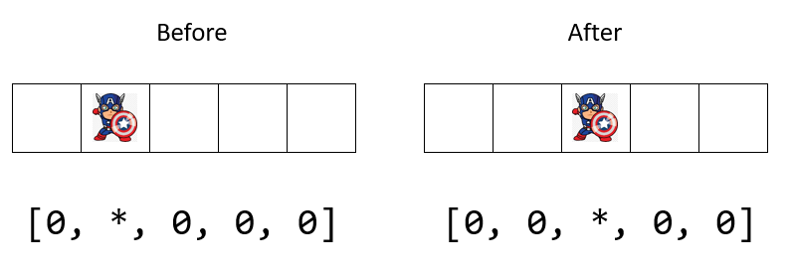

**INPUT**

* An array of 5 character (zero or *)

*Note: Captain America is never on the last cell for this first exercise*

**OUPUT**

* The new array after you have moved Captain America on the right.

**Q1** – This program contains 2 mains steps; can you complete the description the 2 steps?

**Step 1**: Find the position of star

**Step 2**: Write 0 at the position of star and write * at the position of 0

**Q2** – Write the code on space below to complete step 1 and step 2

*TIPS: you should use a function to write this code*

*// your code*

*get array1D*

*for loop*

*if find star inser 0*

*if loob <0*

*stop*

*if loo >4*

*stop*

*print(array1D)*

**Q3** – Share and discuss in groups of 3.

**Q4** – Code on your computer.

**EXERCICE 2**

**PROBLEM:**

Now Captain America can move left or right, depending on the input direction.

This time:

* if Captain America in on the first cell, he cannot go left (he stays at the same position)
* if Captain America in on the last cell, he cannot go right (he stays at the same position)

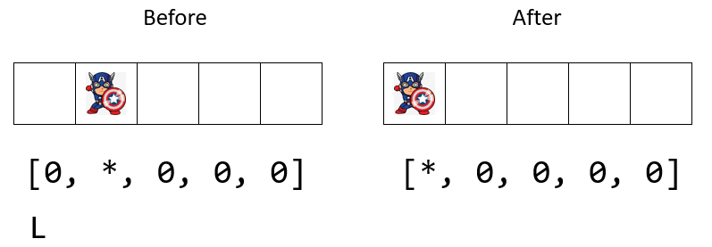l

*Here Captain America can go left*

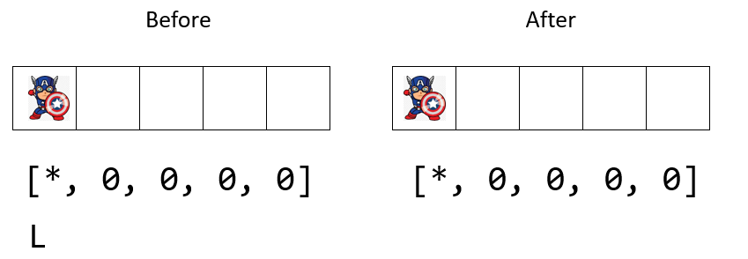

*Here Captain America cannot go left So he stays at the same position*

**INPUT**

* An array of 5 character (zero or *)
* Direction, a character (R or L)

**OUPUT**

* The new array after you have moved Captain America on left or right.

**Q1** – What do you need to update on your previous code?

* I need to…
* I need to…
* I need to…

**Q2** – Write the code on space below:

*// your code*

array=["0", "x", "0", "0",]

iStrue=True

for i in range(len(array)):

    if array[0] == "x" and iStrue:

        iStrue=False

    elif array[i] == "x" and iStrue:

        array[i] = "0"

        array[i-1] = "x"

        iStrue =False

print(array)

**Q3**– Share and discuss in groups of 3.

**Q4** – Code on your computer.

**EXERCICE 3**

**PROBLEM:**

Now Captain America can move left or right but also up and down!!

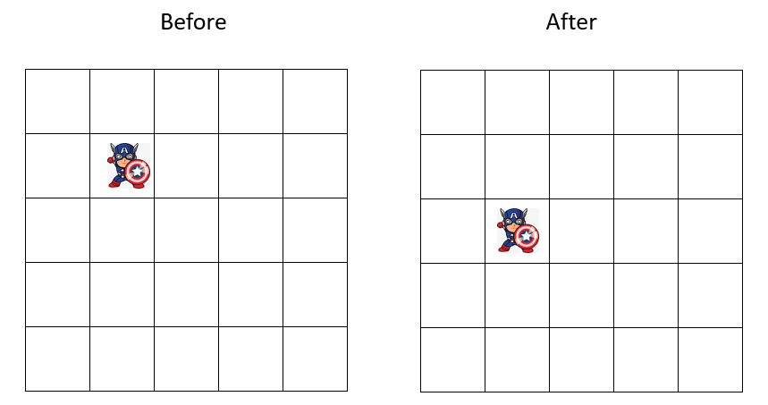

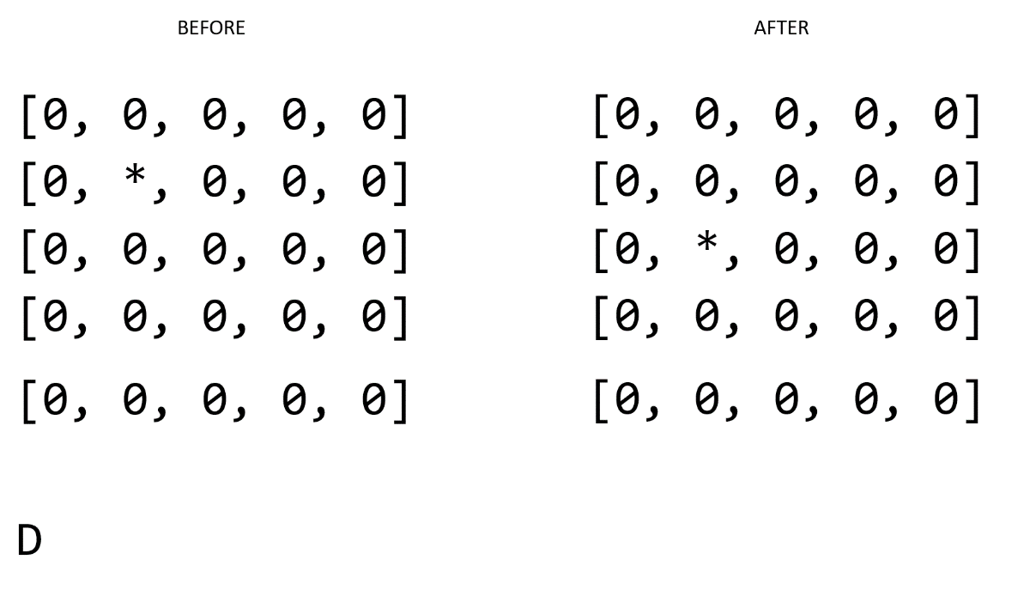

**INPUT**

* An array2D composed of (zero or *)
* Direction, a character (R, L, U, D)

**OUPUT**

* The new array after you have moved Captain America on left or right and up or down.

**Q1** – What do you need to update on your previous code?

* I need to…
* I need to…
* I need to…

**Q2** – Write the code on space below:

*// your code*

**Q3** – Share and discuss in groups of 3.

**Q4** – Code on your computer.

**EXERCICE 4**

**PROBLEM:**

Now Captain America can move left or right but also up and down!!

This time:

* if Captain America in on the first column, he cannot go left (he stays at the same position)
* if Captain America in on the last column, he cannot go right (he stays at the same position)
* if Captain America in on the first row, he cannot go up (he stays at the same position)
* if Captain America in on the last row, he cannot go down (he stays at the same position)

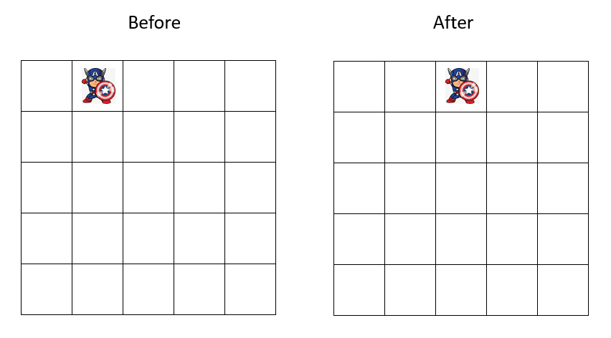

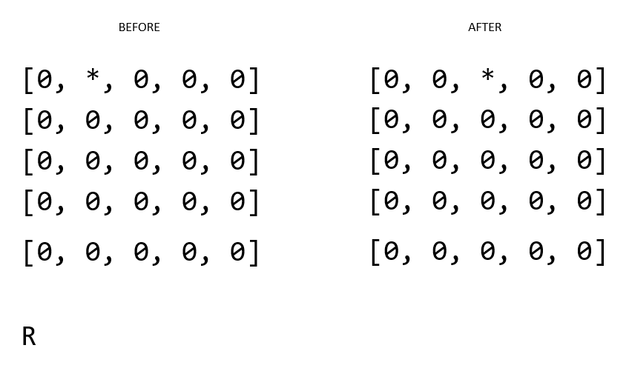

*Here Captain America can go right*

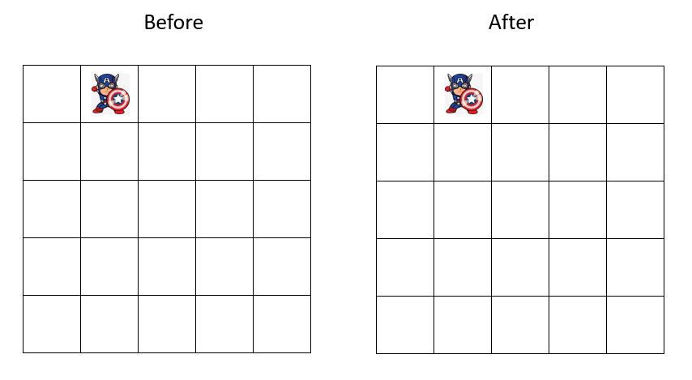

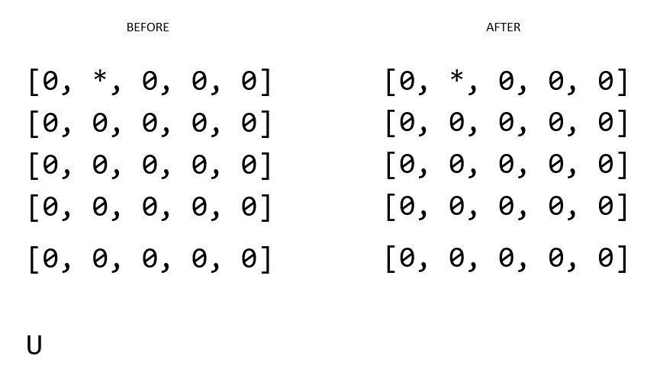

*Here Captain America cannot go up So he stays at the same position*

**INPUT**

* An array2D composed of (zero or *)
* Direction, a character (R, L, U, D)

**OUPUT**

* The new array after you have moved Captain America on left or right and up or down.

**Q1** – What do you need to update on your previous code?

* I need to…
* I need to…
* I need to…

**Q2** – Write the code on space below:

*// your code*

**Q3** – Share and discuss in groups of 3.

**Q4** – Code on your computer.